FB1SL-CLEAR G/L ACCOUNT FOR LEDGER GROUP


This simulation describes how to use T-Code FB1SL to perform G/L Clearing for specific Ledger Group.

In real life, the BSC team responsible for G/L Clearing will need to refer to a MyRequest template for details that you will be enter in the next screens. Refer to separate MyRequest Template training materials for how to fill in a Clearing MyRequest template.

Click to continue.

Explanation | Screenshot
[1] FB1SL is now entered in the Transaction box. | 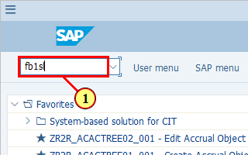
[2] The *Account field is filled out.  This is the account you should find in the MyRequest Template.  This account should have the set up of "Clearing Specific to Ledger Groups" in its G/L Master Data. | 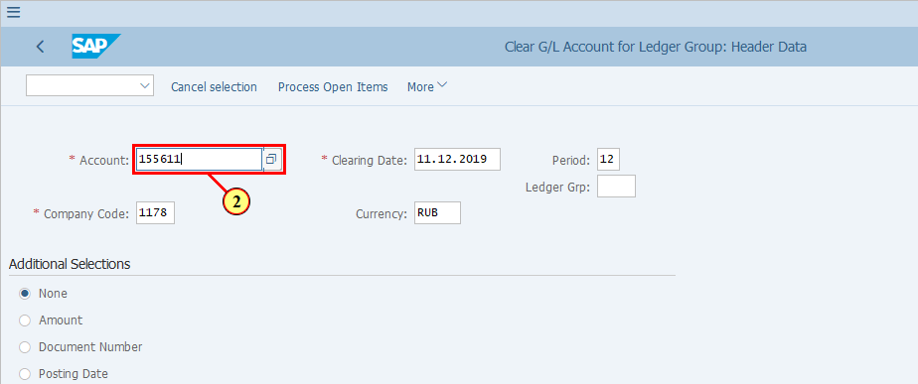
[3] The *Clearing Date field is filled out.  This is by default the current date however you may refer to your MyRequest template for this information. It is important you are posting the clearing to the correct period, especially during month end. | 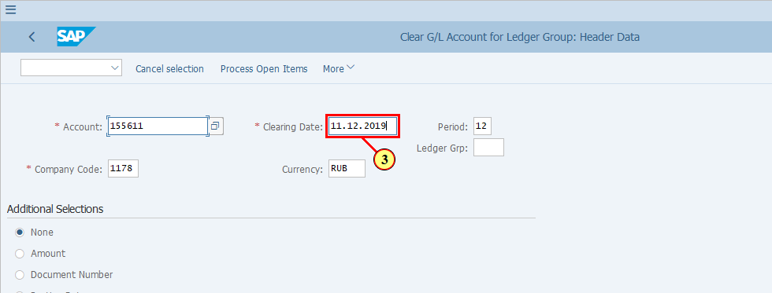
[4] The Ledger Grp field is filled out.  This is also based on what is indicated in your MyRequest template. | 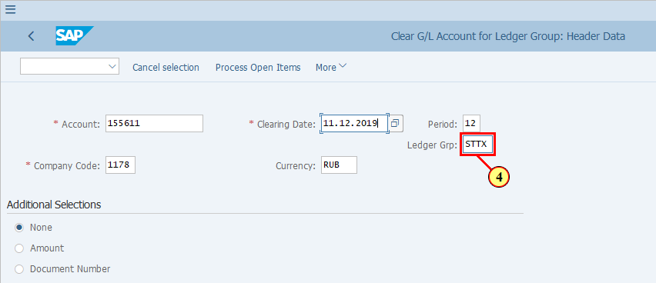
[5] Note: you must also input Company Code here if there's no system default for you. This is based on MyRequest Template too.  Confirm with Enter key. | 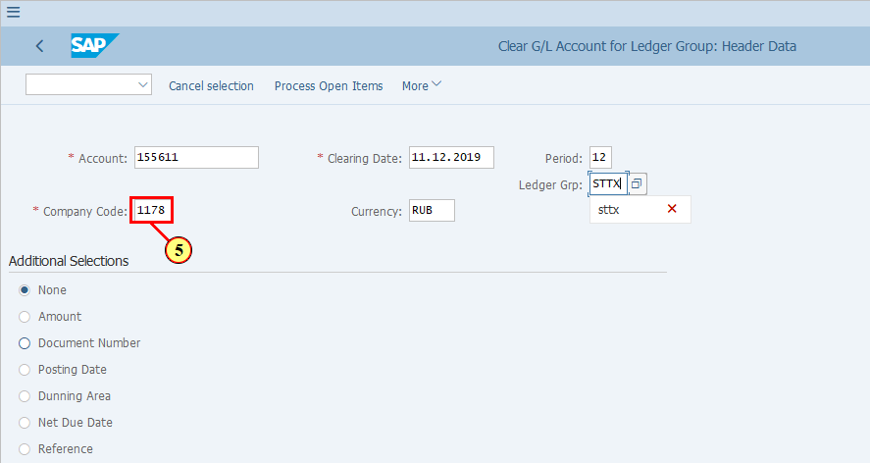
[6] Your MyRequest template contains the information of which line items of the selected G/L accounts should be cleared. This could be based on all these criteria listed here. It is common for users to indicate Document Number or Amount. In this simulation we will use Document Number to select the line items to be cleared.  Document Number is now selected. | 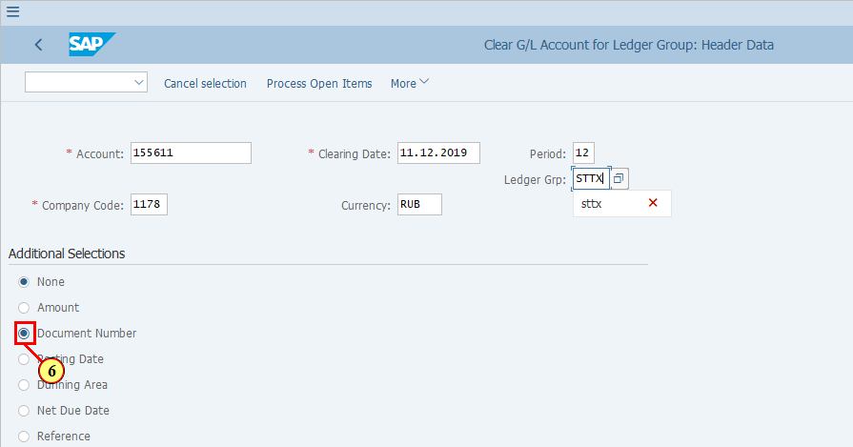
[7] Press ENTER to access the next screen. | 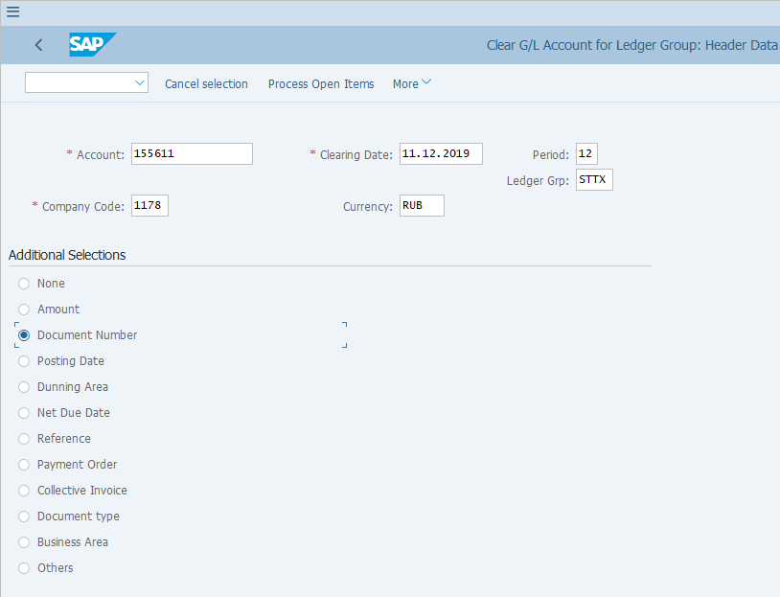
[8] This is the form where you enter the detailed values of your selection criteria. In our example we selected "Document number" therefore we need to enter the Document Numbers of the line items that we wish to clear.  You my enter single Document Numbers or ranges. | 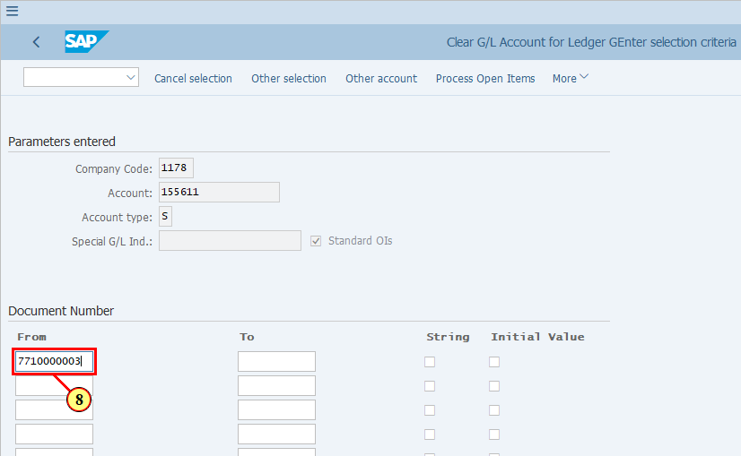
[9] Continue to enter all the Document Numbers you wish to select for clearing. | 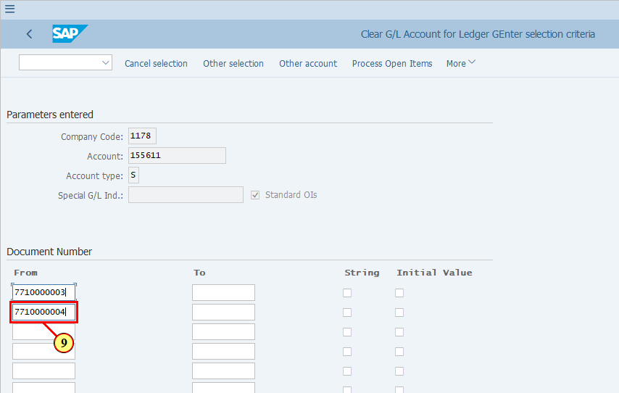
[10] Continue to enter all the Document Numbers you wish to select for clearing. | 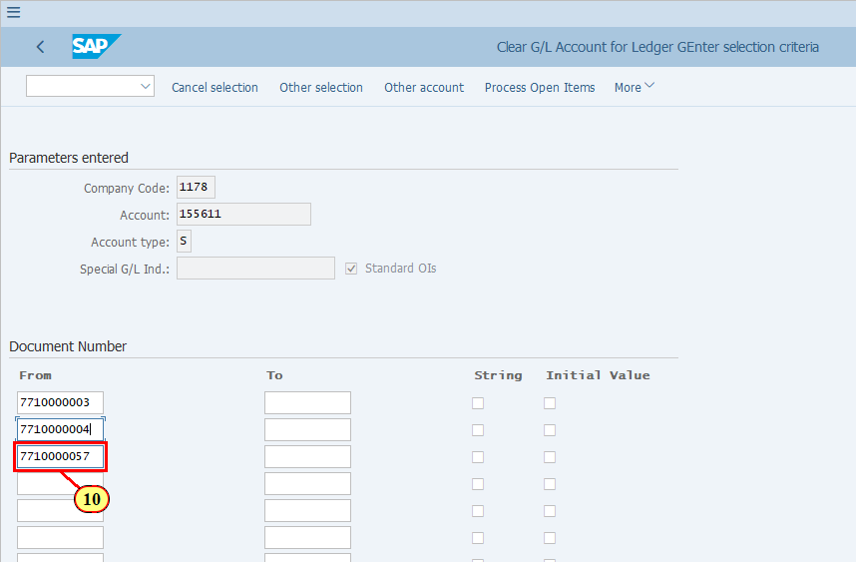
[11] Click Process Open Items .  You can also press Shift+F4. | 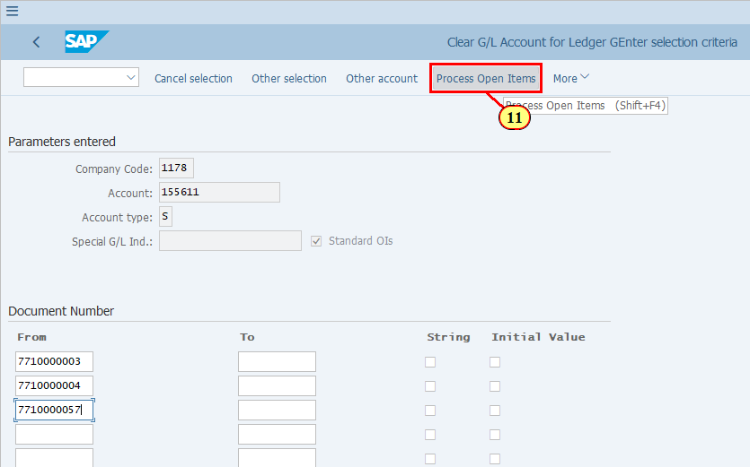
  When you first enter the Process Open Item screen, you will see the amounts are automatically highlighted blue.  If these amounts total to zero in the Clearing Currency that you entered on the selection screen, you can simply proceed to post the clearing document.  If these amounts do not total to zero in the Clearing Currency, you can make your choice once again, or decide to clear some of the items partially.  We will now simulate how to select / deselect items and perform partial clearing. You DO NOT need to do the following if your case is simple and items selected already balance to zero and are ready to be cleared.  Click to continue to see how the buttons work for selecting items.  [12] Click Select All to select all the items shown on the screen. | 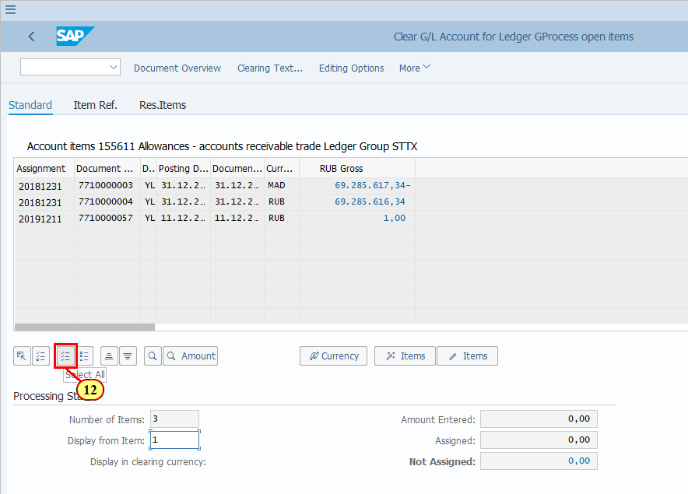
[13] If you don't wish to select all the items on the screen, you can click Items to deactivate your selection, i.e. de-select all. | 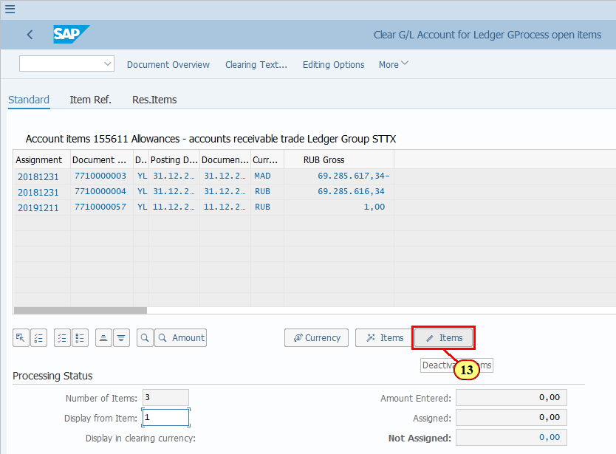
[14] Now you should notice that nothing is selected on the screen, no document number or amount is highlighted blue.  To select an item, double click the amount field. | 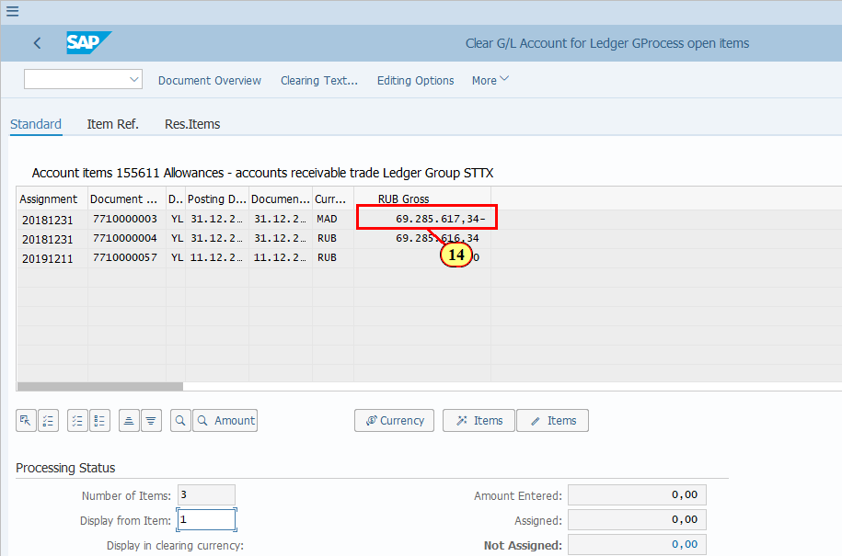
[15] Continue to do so for the next amount that you wish to select for clearing. | 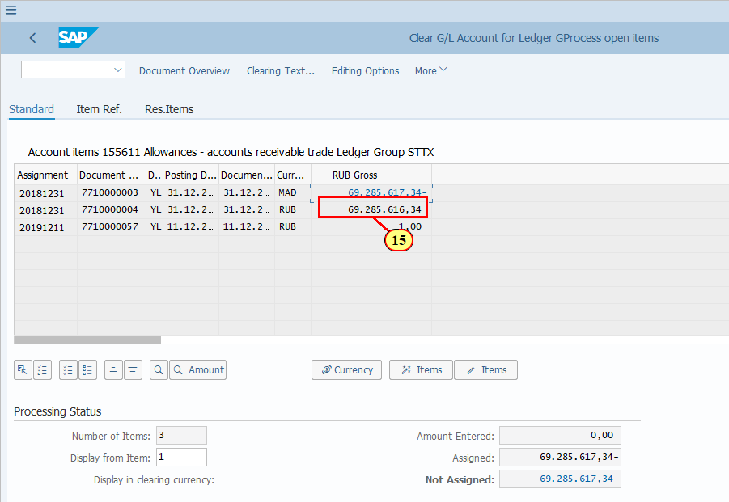
[16] Continue to do so for the next amount that you wish to select for clearing. | 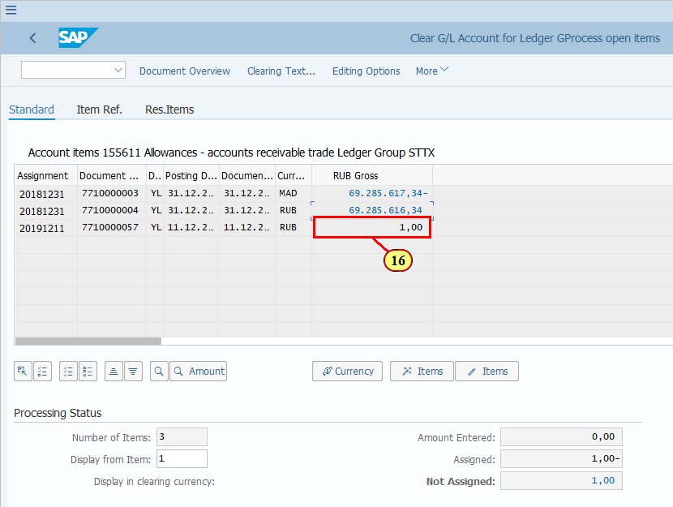
  At this point, as you can see that you have selected the amounts from the items that you wish to clear, and these amounts total to zero.  Amount Enterted: 0.00 - because you didn't enter any additional amount;  Assigned: 0.00 - this is the total of the amounts you selected.  Not Assigned: 0.00 - as all amounts selected add up to zero there is no amount left as "Not Assigned".  From here you can proceed to simulate the clearing document posting and post the document, which will be shown later.  Now let's take a look at the partial clearing scenarios in the next few steps.  Click to continue. | 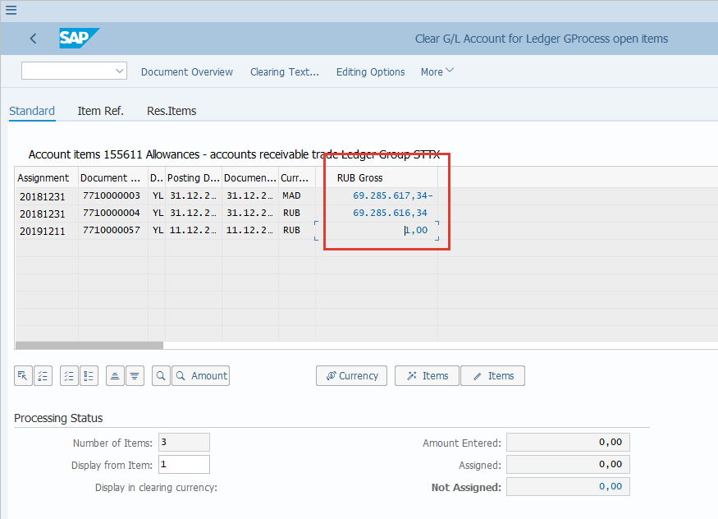
[17] If you have some items which need to be cleared partially, i.e. not the full amount in that line item, then you need to use the other two tabs.  Clicking the Item Ref. tab. | 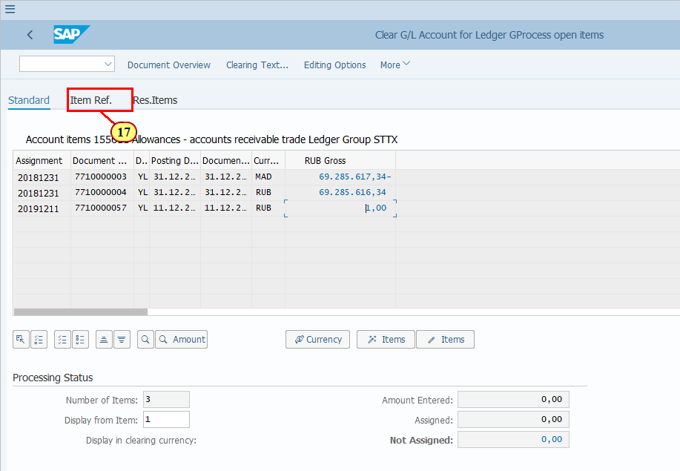
[18] As an example, you only wish to clear the first two items however they do not add up to zero.  What you can do is to clear one of the items partially. You can do so by double clicking on the amount of the item that you want to clear partially.  Double click on the Payment Amount field of the first item. Or alternatively you can manually enter the amount in this field which equals to the amount that can be cleared. | 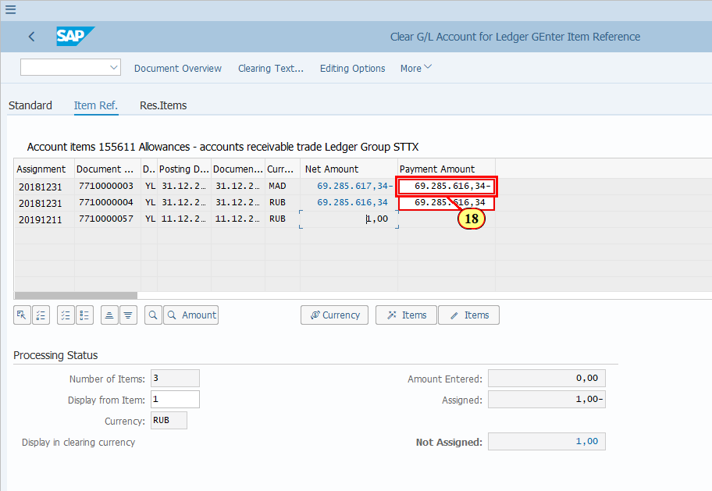
  Now you can see that the Assigned and Not Assigned amounts are zero again, which means you can proceed with posting of this clearing.  This can also be done via Res. Items tab. which will be shown in the next few steps.  Difference between using tab Item Ref. and Res.Items:  - Item Ref. assumes a partial clearing leaving all items still open but the total amount uncleared has reduced  - Res. Items assumes a residual item is to be left representing the residual amount of the item that was selected to have a residual item. Res. Items method clears all items but creates a new residual item.  Click to continue to explore Res.Items tab. | 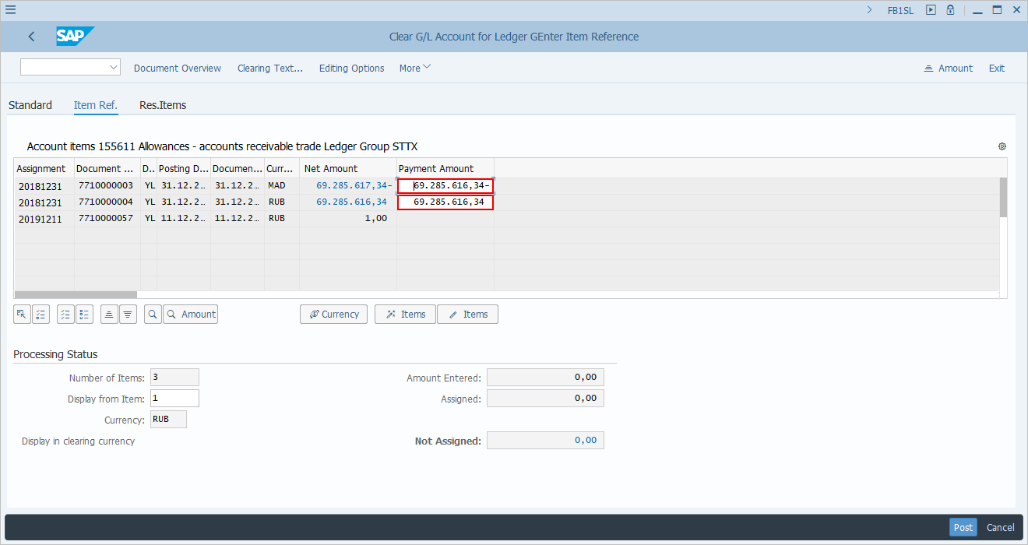
[19] Clicking the Res.Items tab selects it. | 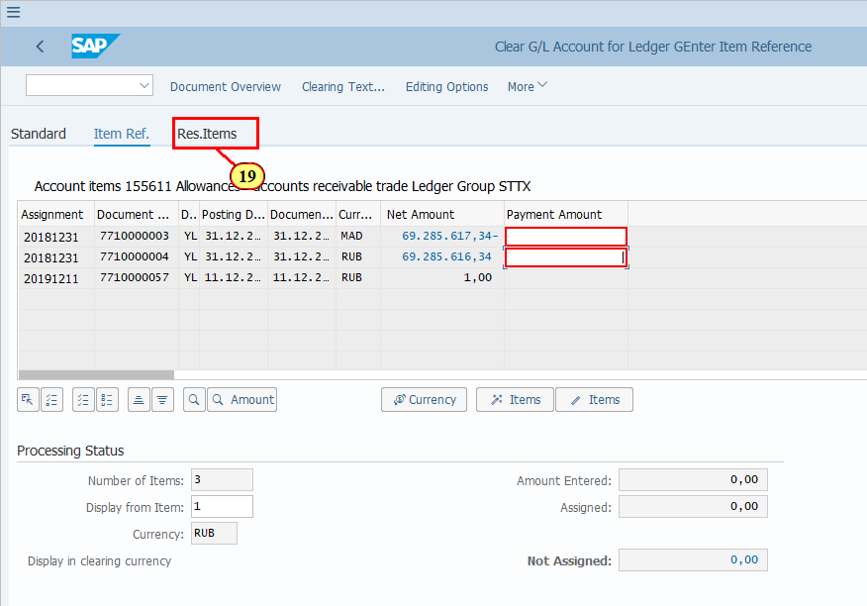
[20] Decide where you want to leave the residual item. Double click on the red box for that corresponding item to fill the amount of residual item in the Residual Items field. | 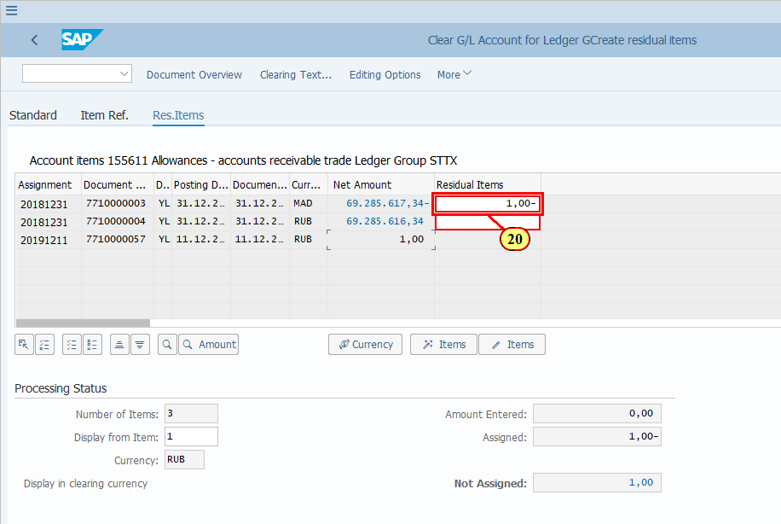
  Now you can see that the Assigned and Not Assigned amounts are zero again, which means you can proceed with posting of this clearing.  Click to continue to see how the clearing document based on all the previously explained scenarios are simulated and posted. | 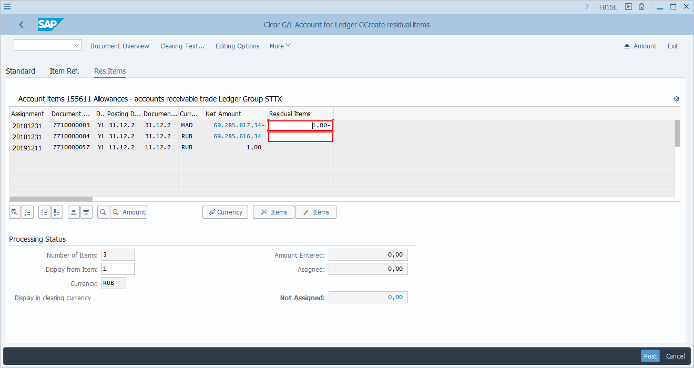
[21] Click More . | 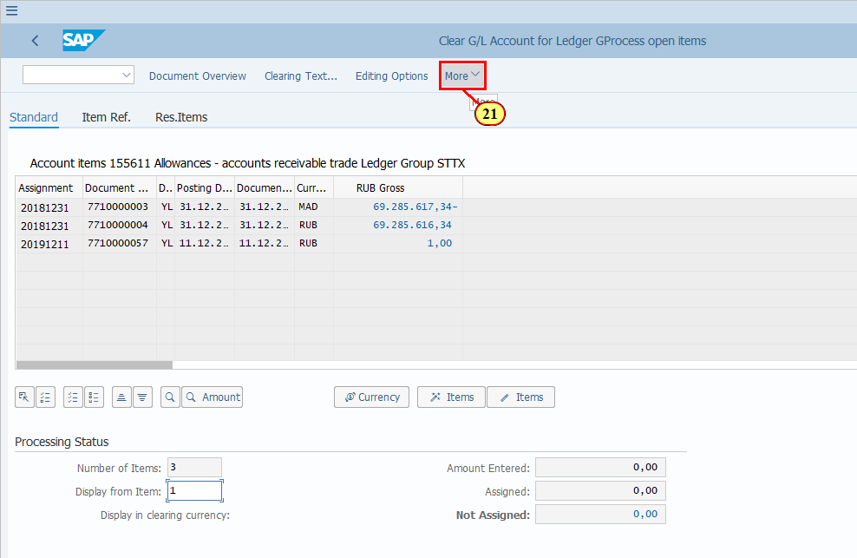
[22] Clicking the Simulate menu item executes it.  You can also press s. | 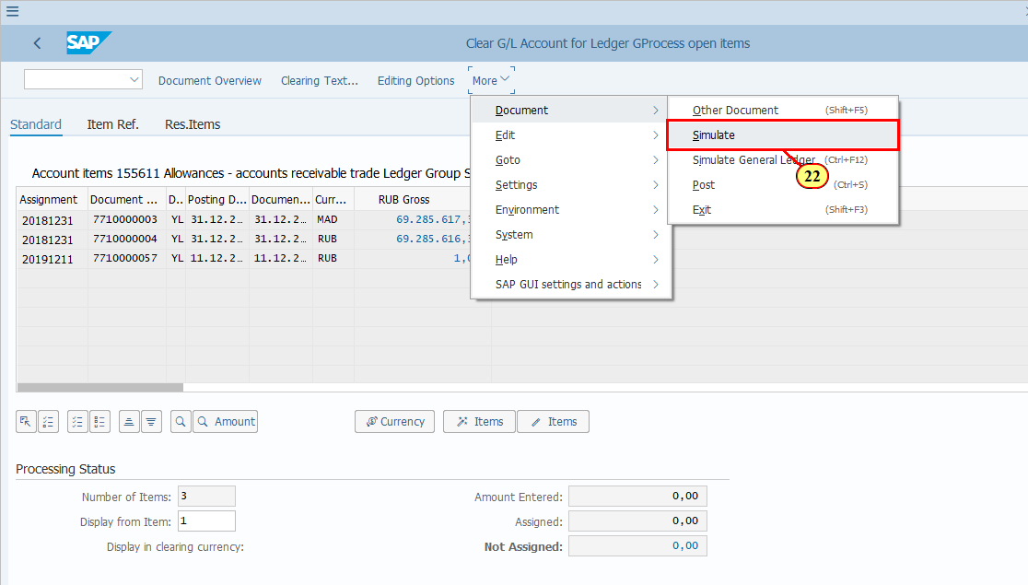
[23] When you simulate the clearing posting, you should check the amounts in different currencies because there may be exchange rate differences posted only in certain currencies but not all.  Click Display Currency .  You can also press F8. | 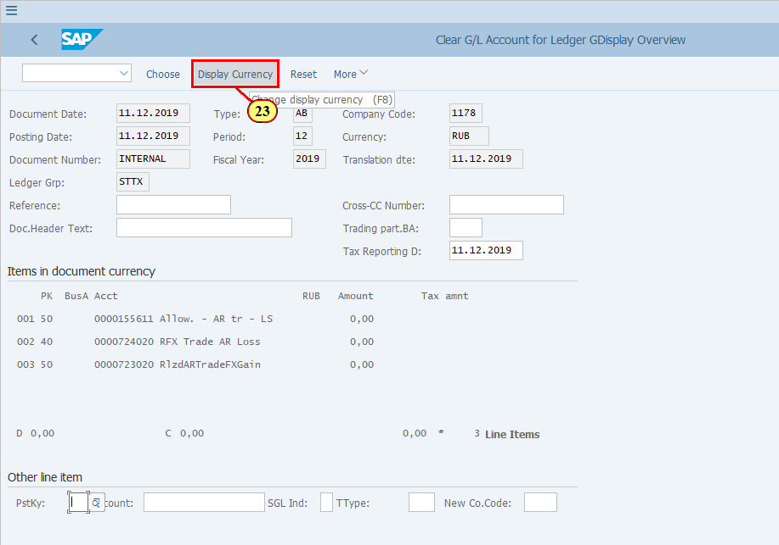
[24] Select to display amount to be posted in Local Currency. | 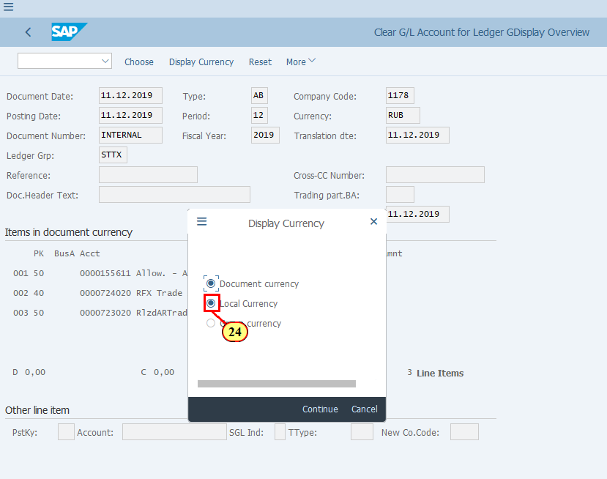
[25] Click Continue .  You can also press Enter. | 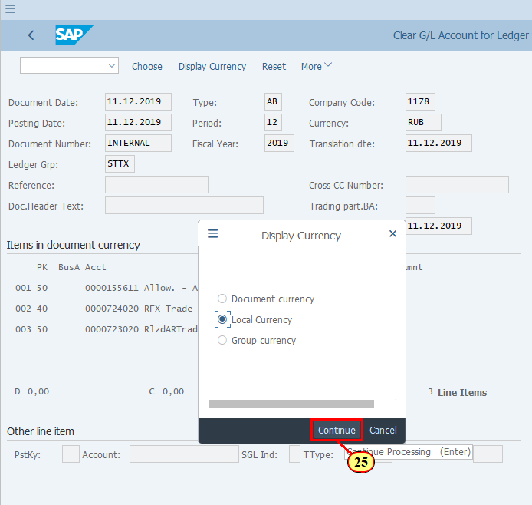
[26] Click Display Currency .  You can also press F8. | 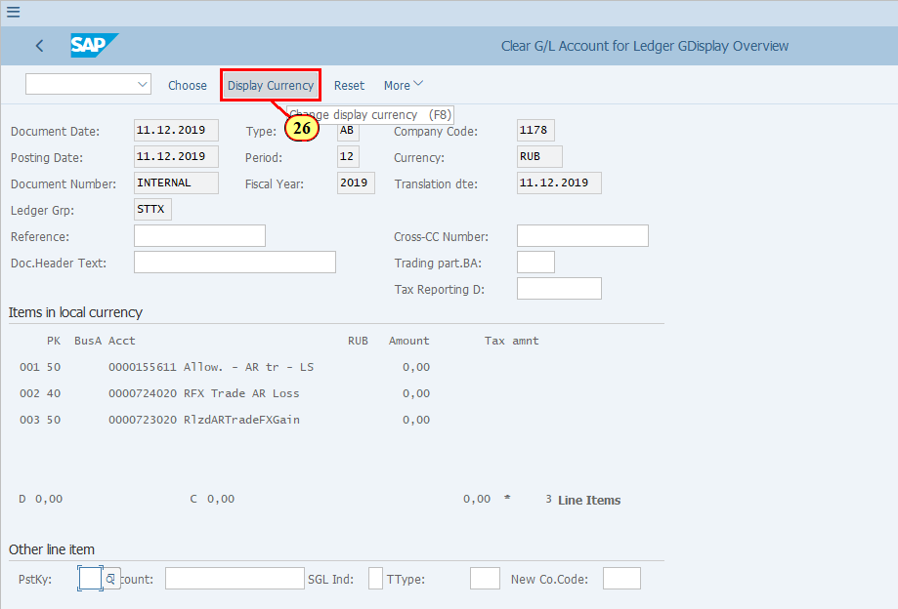
[27] Continue to display all the available currencies in this ledger group. Note in our example we are using Ledger Group STTX, which has only LC1 and LC2 but not LC3. | 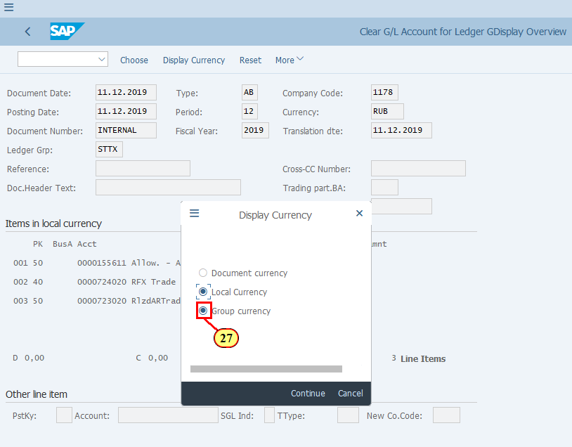
[28] Click Continue .  You can also press Enter. | 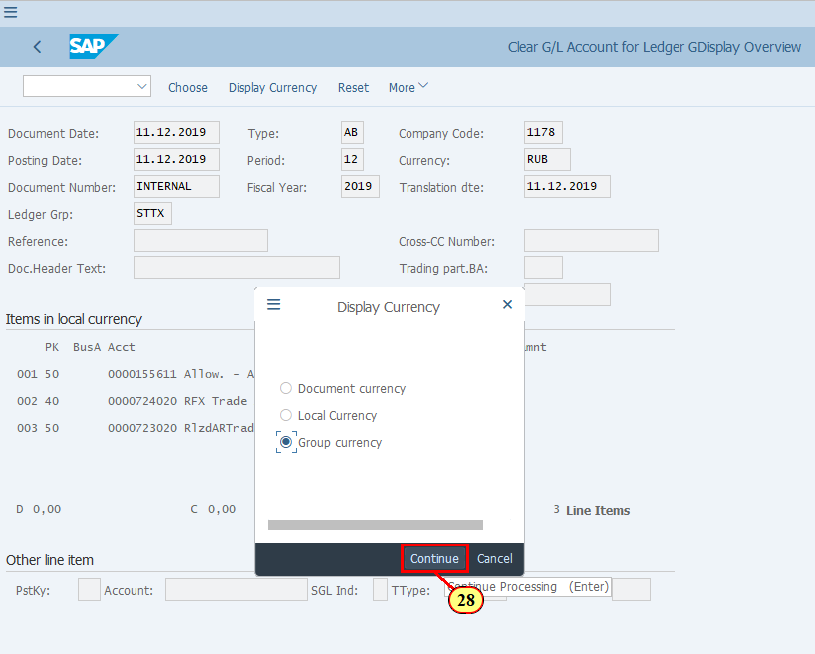
[29] Click Post after you are happy with your simulated document. | 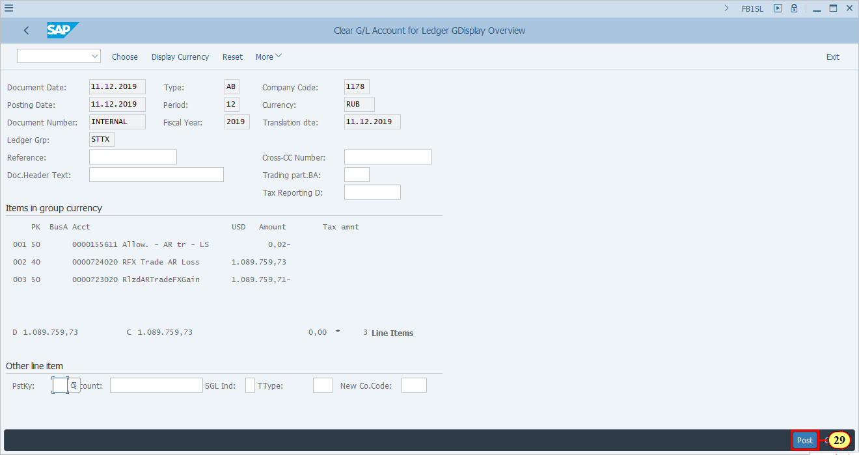
[30] /nfb03 is now entered in the Transaction box. | 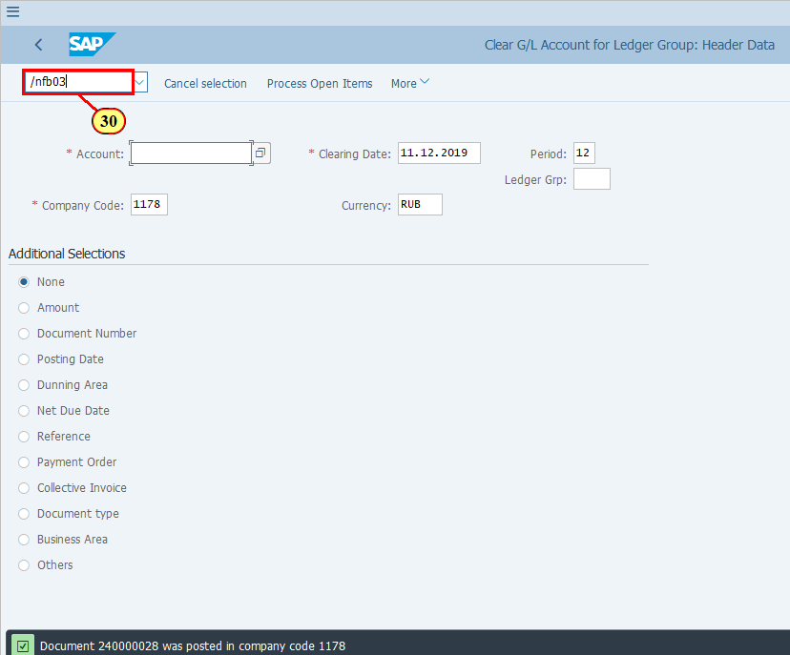
[31] Press ENTER . | 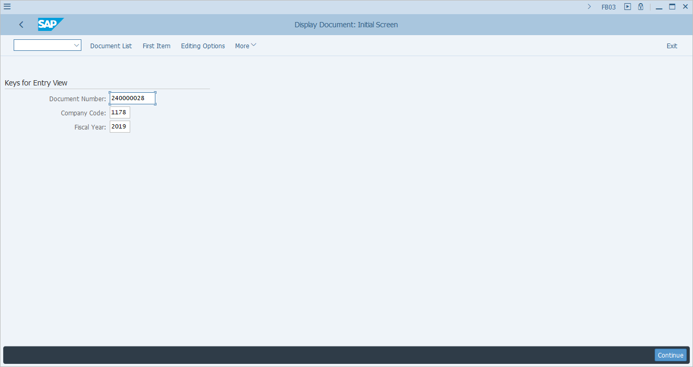
  You may go to G/L Line Item reports (FAGLL03 or FAGLL03H) to display the items that you just cleared, which should now be shown as cleared instead of Open.  [32] /nfagll03h is now entered in the Transaction box. | 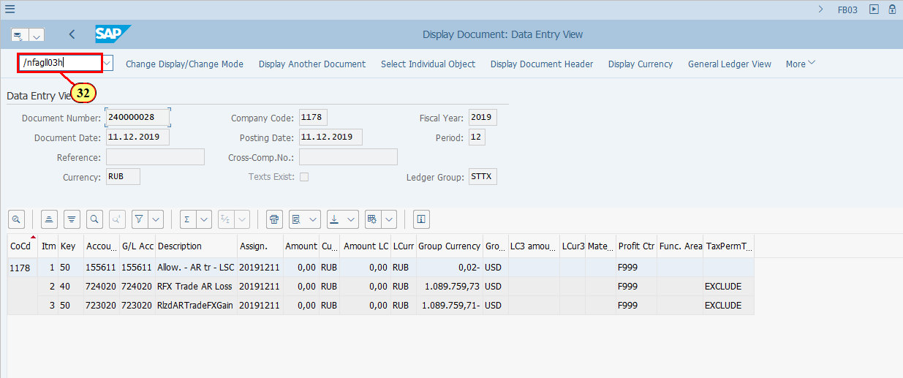
[33] Now in T-code FAGLL03H - G/L Line Item Browser, you may display cleared items.  Fill in the G/L Account field. | 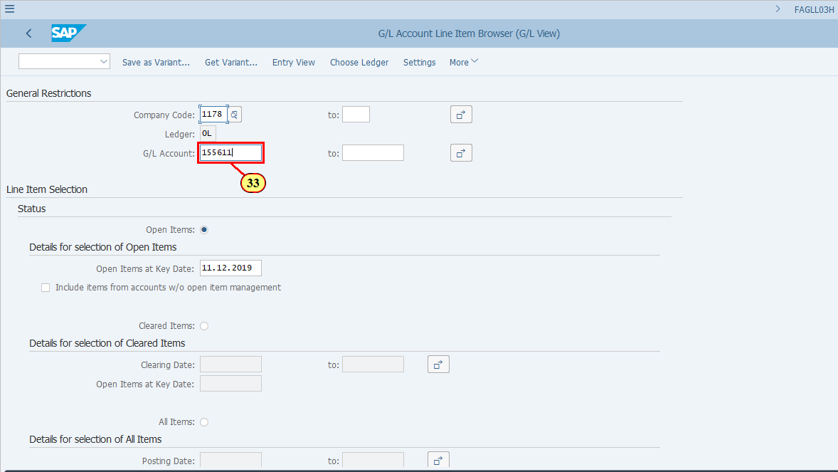
[34] Click Choose Ledger .  You can also press Ctrl+F3. | 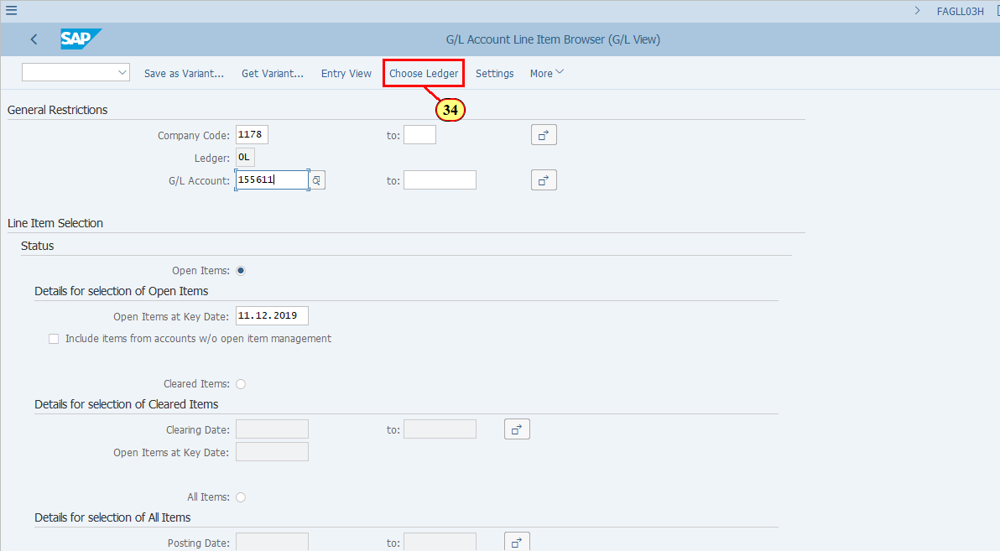
[35] The *Ledger field is filled out. | 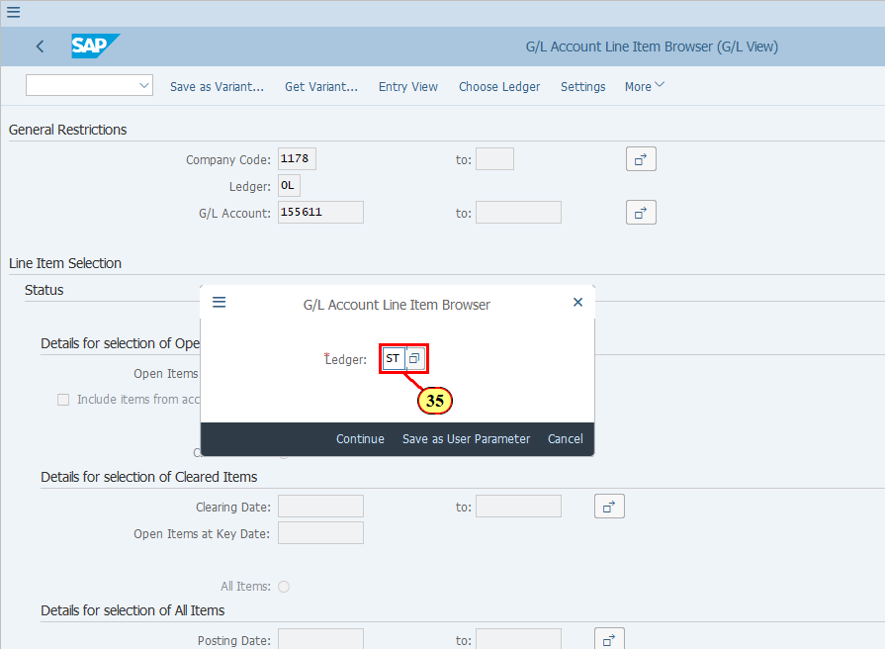
[36] Click Continue .  You can also press Enter. | 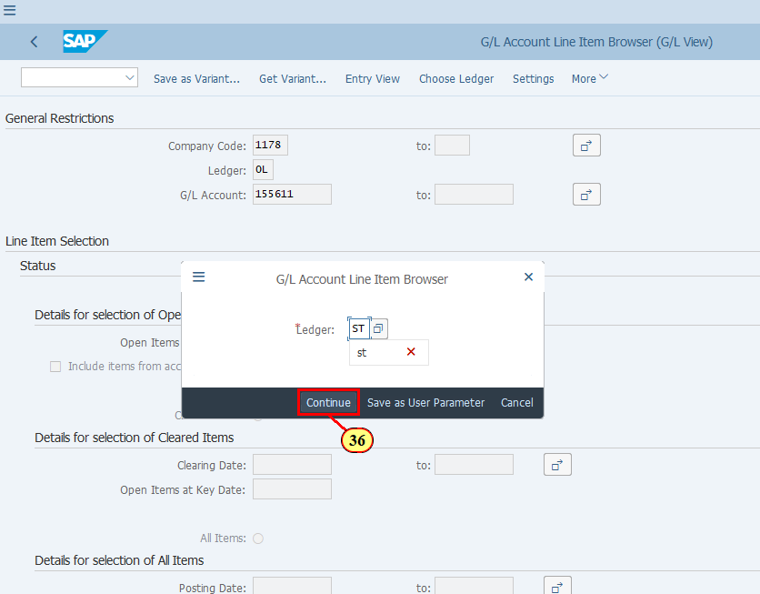
[37] Click Cleared Items . | 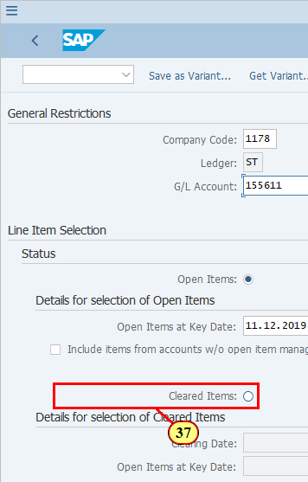
[38] The Clearing Date field is filled out. | 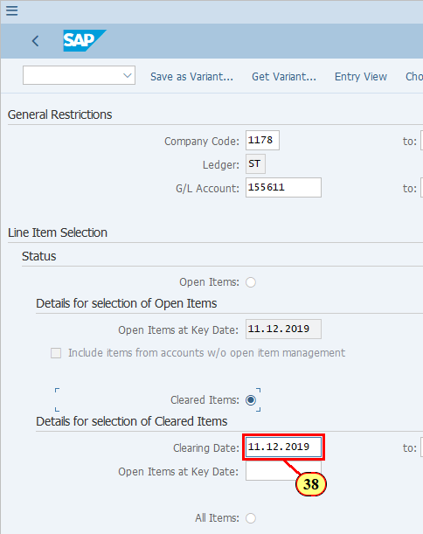
[39] Click Execute .  You can also press F8. | 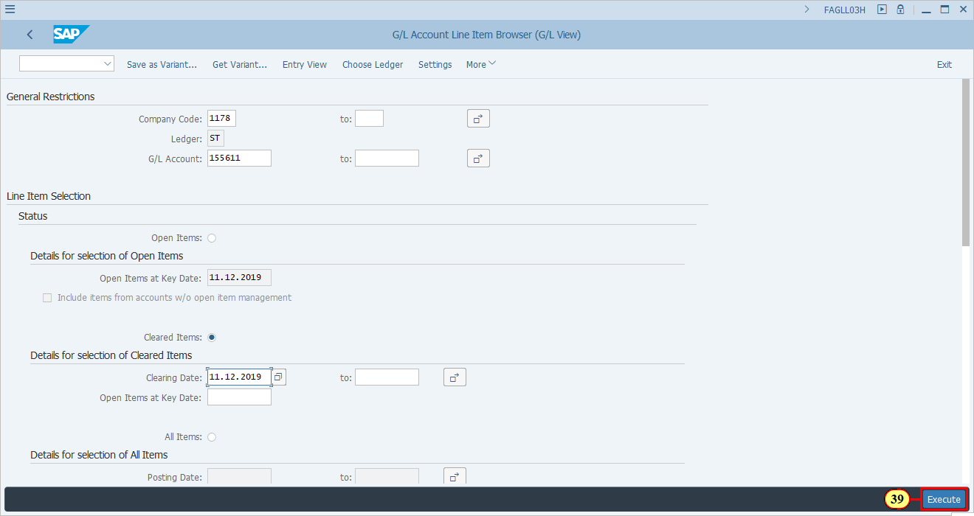
  In the "Sidebar" find your layout which shows the relevant fields of clearing and choose it so that you can display your line items to confirm that they are cleared. | 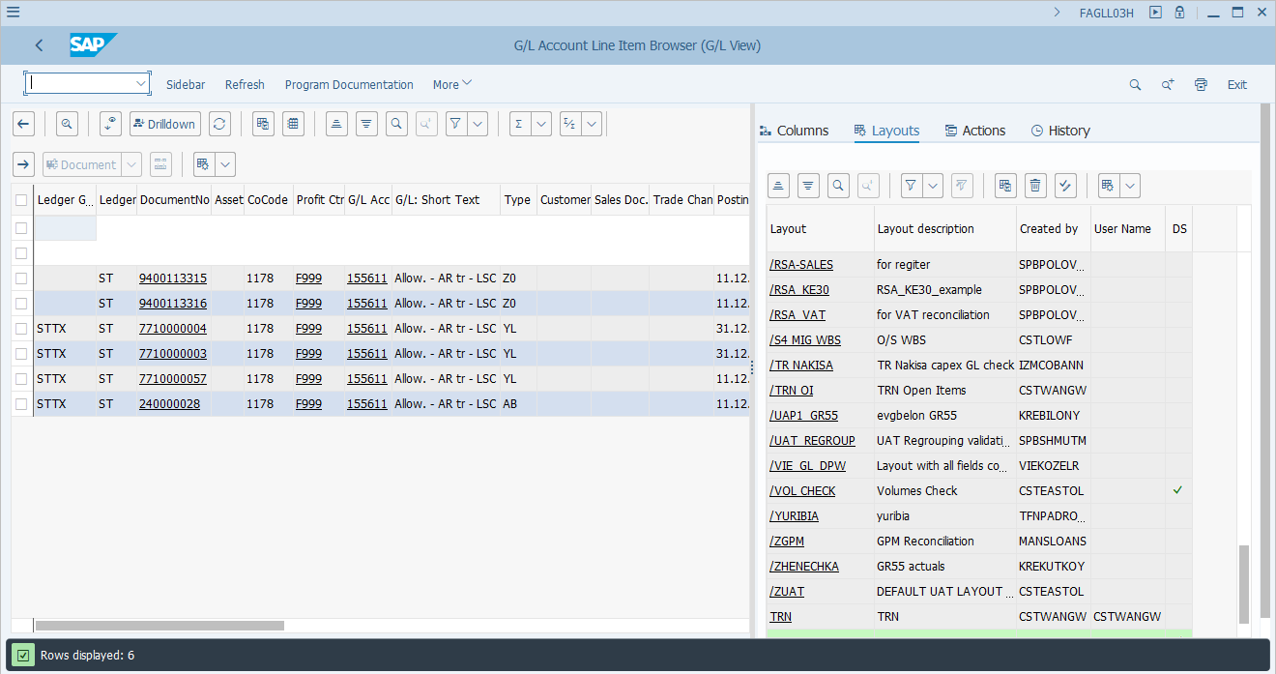
[40] Click Show/Hide Sidebar (F7) .  You can also press F7. | 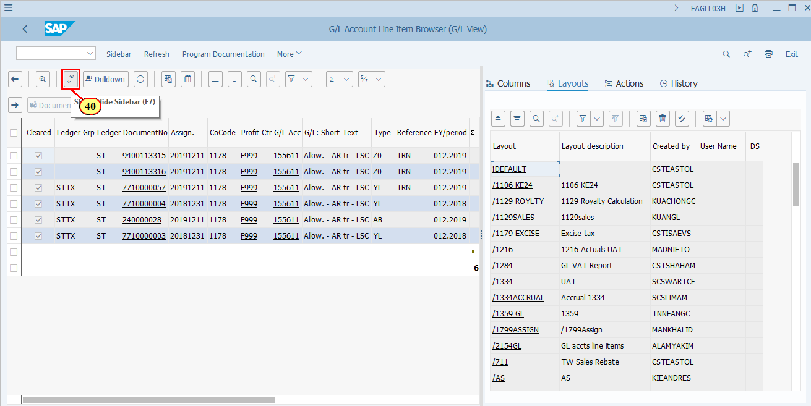
[41] Click Change Layout... to bring more clearing related columns to display. | 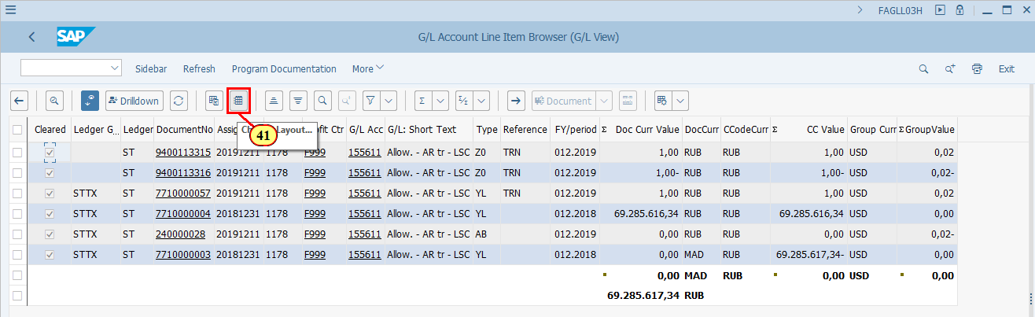
[42] Click Column Name . | 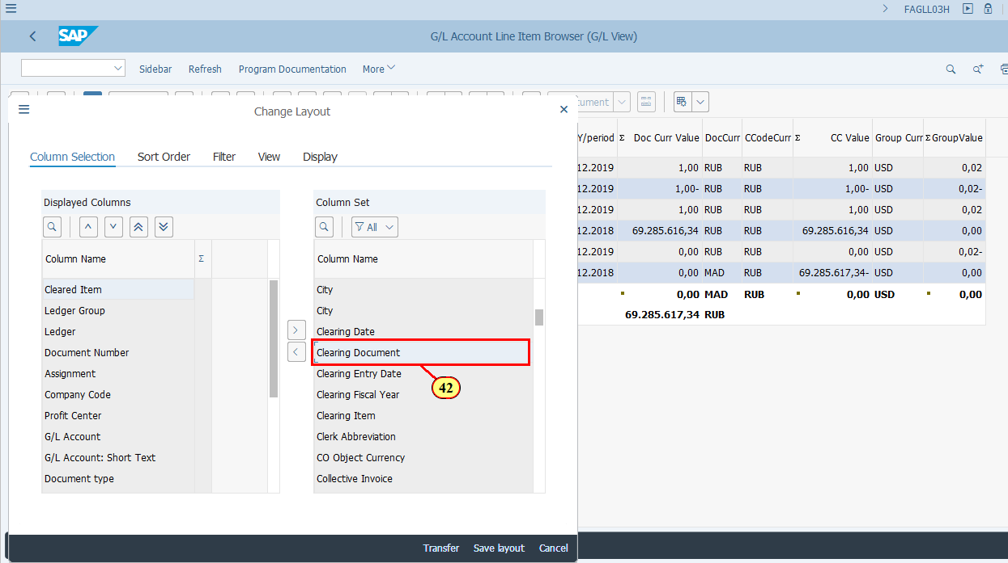
[43] Click Column Name .  Press Ctrl key while performing the action. | 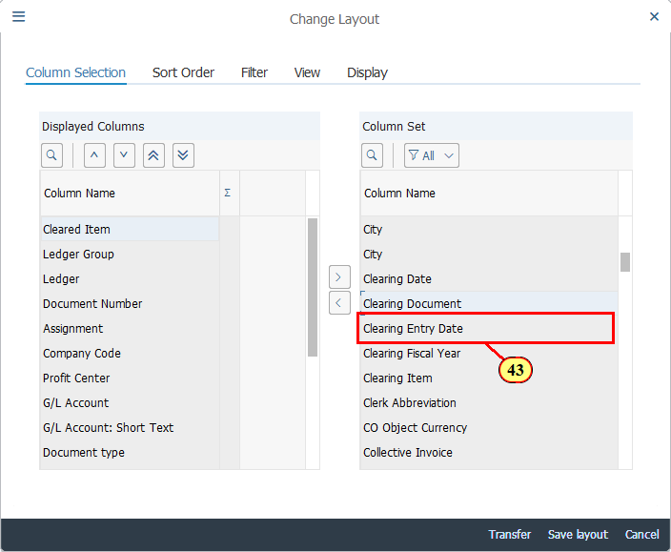
[44] Click Column Name .  Press Ctrl key while performing the action. | 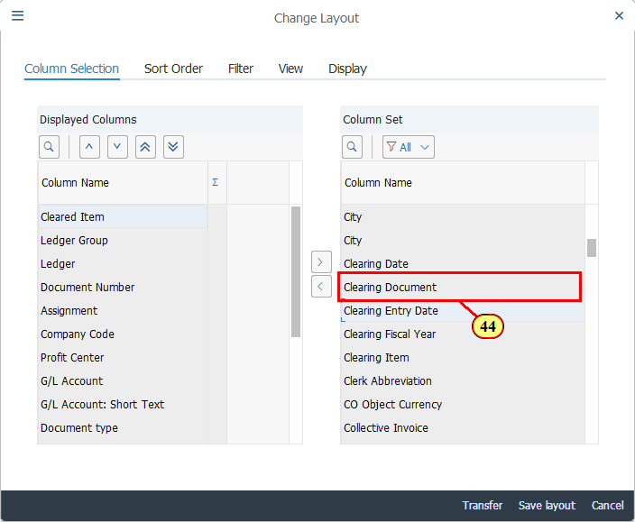
[45] Click Column Name . | 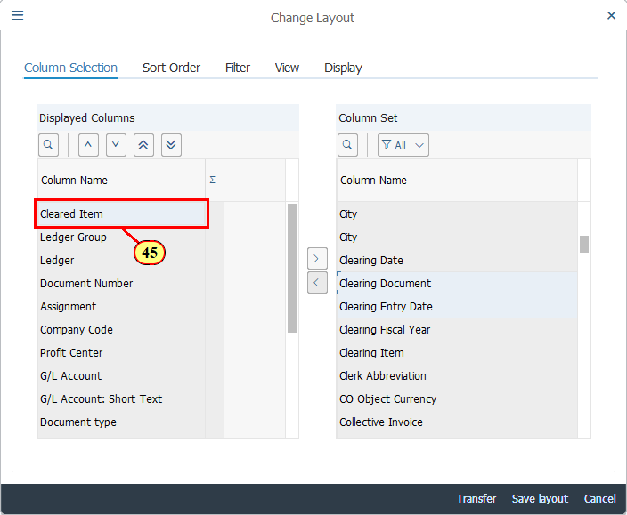
[46] Click Show Selected Fields .  You can also press F7. | 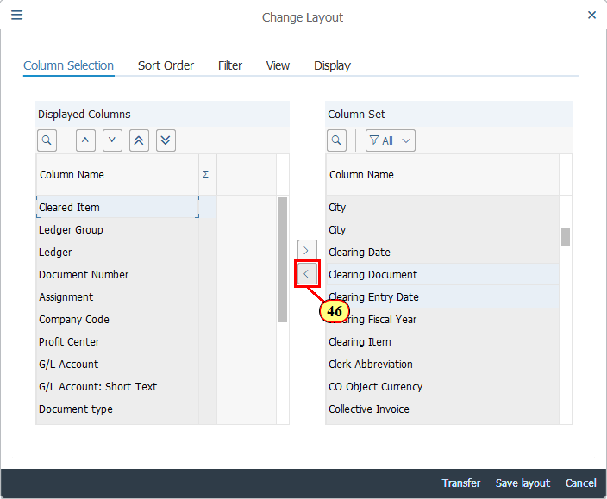
[47] Click Transfer .  You can also press Enter. | 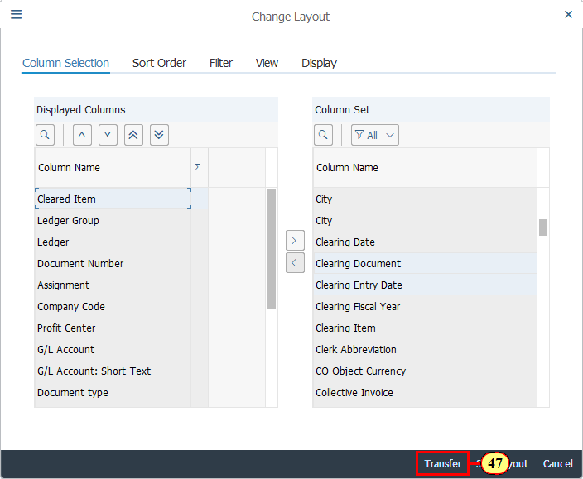
[48] To do a Subtotal based on Clearing Document, click . | 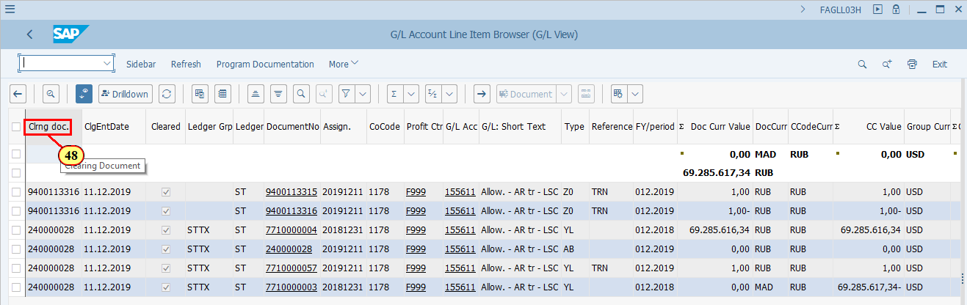
[49] Click Subtotals . | 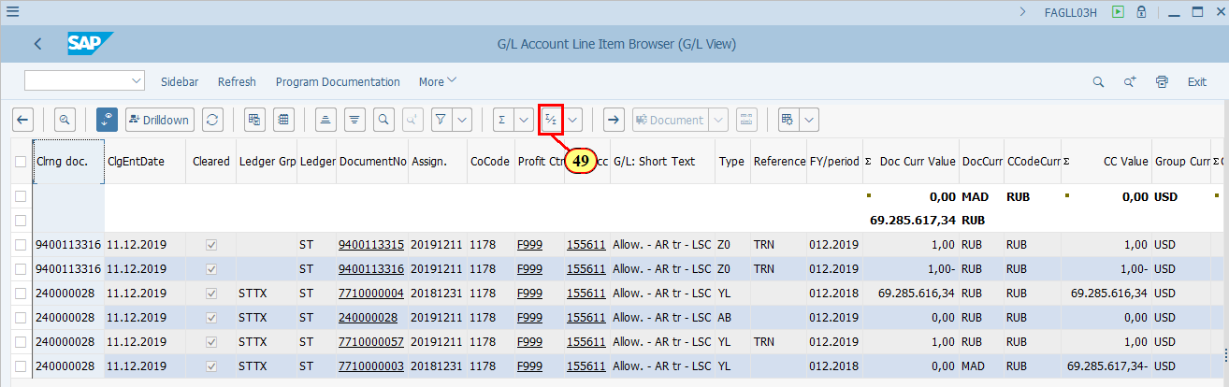
  Now you can see that the items you have selected for Ledger specific clearing in ledger STTX are now cleared and posting is made to document 240000028 with USD 0.02 in LC2. | 